Industrial Training
On
Python and Django
Completed at

Webguru Infosystems Pvt Ltd, Kolkata

An industrial training report submitted in
Partial fulfilment of the requirements for the degree of
Diploma in Computer Science and Engineering

Batch 2, Group A
Student Name | Student Code
Jesu Khamrui | BWU/DCS/23/095
Subrata Maity | BWU/DCS/23/063
Bidhan Patra | BWU/DCS/23/061
Dibya Mandal | BWU/DCS/23/114

Project Name:
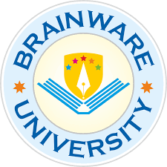
Library Management

Department of Computer Science and Engineering

Brainware University
2024-2025
Instructor Signature

